# **Symmetric Tree**

Given the root of a binary tree, *check whether it is a mirror of itself* (i.e., symmetric around its center).

**Example 1:**

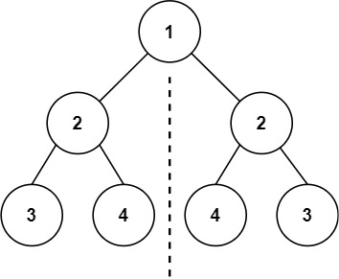

**Input:** root = [1,2,2,3,4,4,3]

**Output:** true

**Example 2:**

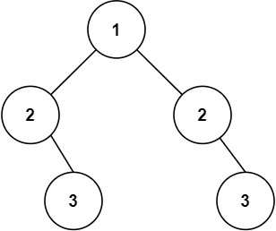

**Input:** root = [1,2,2,null,3,null,3]

**Output:** false

**Constraints:**

* The number of nodes in the tree is in the range [1, 1000].
* -100 <= Node.val <= 100

/**

* Definition for a binary tree node.

* public class TreeNode {

* public int val;

* public TreeNode left;

* public TreeNode right;

* public TreeNode(int val=0, TreeNode left=null, TreeNode right=null) {

* this.val = val;

* this.left = left;

* this.right = right;

* }

* }

*/

public class Solution

{

public bool IsSymmetric(TreeNode root)

{

return IsSame(root.left,root.right);

}

bool IsSame(TreeNode r1, TreeNode r2)

{

if((r1== null && r2!= null) || (r2== null && r1!= null) ||

((r1 !=null && r2 != null) && (r1.val != r2.val)))

{

return false;

}

return ((r1 == null && r2 == null) ||

(IsSame(r1.left, r2.right) && IsSame(r1.right,r2.left)));

}

}